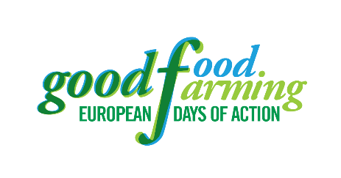
Strasbourg, 22 October 2019
Dear Members of the European Parliament,
We ‒ farmers, bee-keepers, cooks, civil society organisations, activists, consumers, young and old from urban and rural areas across Europe ‒ are calling on you to serve up a better future for farming. We face a climate and ecological emergency and massive loss of small farming communities across Europe. Without deep reforms of the EU’s Common Agricultural Policy (CAP) and a move towards coherent policies for sustainable European agri-food systems, we will not be able to farm and consume food in a healthy and environmentally-friendly way, that is low in emissions and socially acceptable.
Science, including the latest IPBES and IPCC reports, tells us that we must act urgently and decisively to prevent further catastrophic climate shift and the collapse of biodiversity. All evidence, including the European Commission’s own assessments, shows that the current CAP fails farmers, the climate and nature. It is unable to secure fair revenues and generation renewal, it fails to protect diverse, small-scale farms from bankruptcy, land grabbing, speculation and urbanisation. It fails animal welfare and biodiversity. It escalates unsustainable trade between the EU and other countries, notably of the Global South. And ultimately, it threatens food sovereignty.
During the European elections this year, many young and concerned citizens across Europe put their faith in you. They demand sustainable and socially-just solutions, not business as usual. Many thousands across Europe have rallied in support of fair and sustainable food production, not least at the 75 events in 21 countries during the ‘good food good farming days’ this October. Today, [hundreds] have come to Strasbourg ‒ carrying the calls of thousands more ‒ to ask you to change the current food and farming systems.
The post 2020 CAP must bring answers to the ecological, social and economic challenges we face. We urge you to use your Parliamentary mandate to work towards a new CAP that will tackle the climate crisis, reverse the rapid loss of biodiversity, ensure healthy and sustainable consumption and production. It must deliver quality rural employment and decent livelihoods for our farmers and rural communities, protecting them from harmful pesticides. Farmers, globally, are among the first to suffer from the impact of climate breakdown, biodiversity collapse and soil degradation.
We call on all Members of the European Parliament to distance yourselves from the business-as-usual attitude of earlier reform negotiations. Time is running out. You must accelerate and finance an agricultural transition in farming to:
- end the loss of small-scale community-based farming and deliver decent working conditions for farmers and farm workers globally with a CAP that combats market imbalances and injustices.
- stop blind per-hectare farm payments and replace them by targeted funding and support that promotes the transition to more sustainable systems such as organic farming and agroecology. Public money must be spent on public goods, serve communities and consumers; not corporate profits.
- tackle the climate crisis, restore soil-fertility and biodiversity, protect water, reduce energy- and chemical dependencies, and promote animal welfare while reducing the current unsustainable levels of production and consumption of animal products.
- Prioritise seasonal, local and fair production of fruits, vegetables, grains, dairy and meat products ensuring access to healthy, nutritious, and affordable diets for all.
Many organisations stand ready to work with you constructively to make the necessary changes in the CAP, the budget and other relevant instruments necessary to restore good food and good farming.

Initiators:

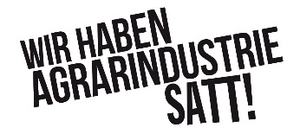

Also supported by:
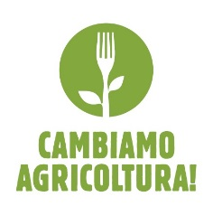
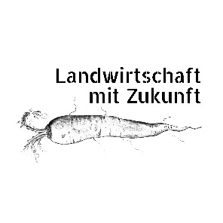

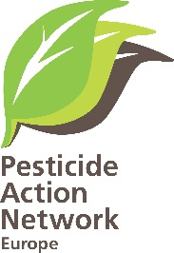

IPBES - Intergovernmental Platform on Biodiversity and Ecosystem Services
IPCC - Intergovernmental Panel on Climate Change

